**Evalue-2: Qn:15**

**Anonymous Function:**

Anonymous function is that a function without names.

It does not have its own identity. But the anonymous function can be assigned to variables. When defined without any names it will throw an error.

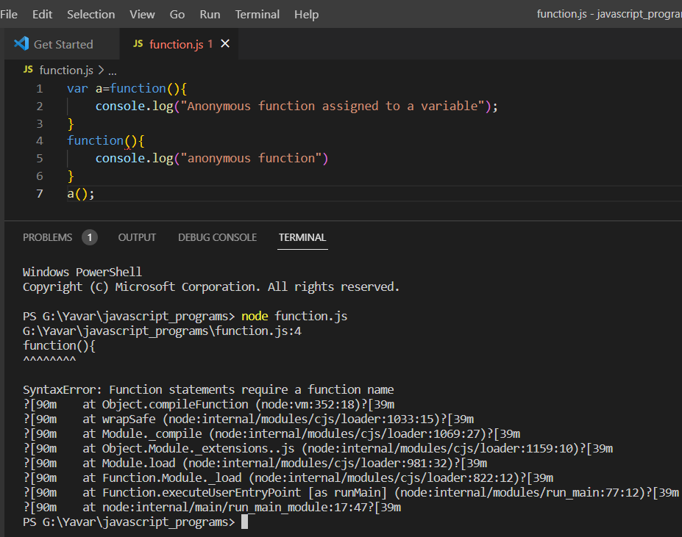

Anonymous functions are often arguments being passed passed to higher-order functions or used for constructing the result of a higher order function that needs to return a function.